Insert your centre number, name and candidate number into the header above.
Save this evidence document as evidence_ followed by your centre number_ candidate number. For example: evidence_ zz999_9999
Screenshots or program listings must be copied into appropriate cells in the following table.
Examiners must be able to read the contents including any screenshots without the use of a magnifying glass. Answers that are not readable or missing will not be awarded any marks.
Save this evidence document at regular intervals, for example every 10 minutes.
Question 1
Part 1(a)
{Copy and paste the program code listing for question 1(a) here}

#main
Name=["[NULL]" for _ in range(11)]
Mark=[-1 for _ in range(11)]

Part 1(b)
{Copy and paste the program code listing for question 1(b) here}

def ReadHighScores():
global Name
global Mark
fr=open("HighScore.txt",'r')
for i in range(10):
Name[i]=fr.readline().strip()
Mark[i]=int(fr.readline().strip())
fr.close()

Part 1(c)
{Copy and paste the program code listing for question 1(c) here}

def OutputHighScores():
print("PlayerName | Score")
for i in range(11):
if Name[i]!="":
print(f"{Name[i]} {Mark[i]}")

Part 1(d)(i)
{Copy and paste the program code listing for question 1(d)(i) here}

#main
Name=["[NULL]" for _ in range(11)]
Mark=[-1 for _ in range(11)]
ReadHighScores()
OutputHighScores()

Part 1(d)(ii)
{Copy and paste the screenshot for question 1(d)(ii) here}

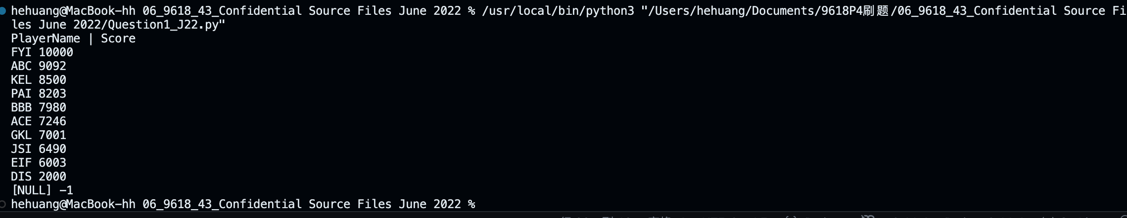

Part 1(e)(i)
{Copy and paste the program code listing for question 1(e)(i) here}
#main
Name=["[NULL]" for _ in range(11)]
Mark=[-1 for _ in range(11)]
ReadHighScores()
OutputHighScores()

Invalid=True
while Invalid:
name=input("Enter a new player name(3 characters ONLY). ")
score=int(input("Enter a new player score(Between 1 and 100000 inclusive). "))
if len(name)==3 and score>=1 and score<=1000000:
Invalid=False
else: print("INVALID name or score")

Part 1(e)(ii)
def NewtopScores(name, mark):
global Mark
global Name
temp=-1
for i in range(10):
if Mark[i]<mark:
temp=i
break
if temp!=-1:
for k in range(10,temp+1,-1):
Name[k]=Name[k-1]
Mark[k]=Mark[k-1]
Name[temp]=name
Mark[temp]=mark

Part 1(e)(iii)
{Copy and paste the program code listing for question 1(e)(iii) here}

#main
Name=["[NULL]" for _ in range(11)]
Mark=[-1 for _ in range(11)]
ReadHighScores()
OutputHighScores()

Invalid=True
while Invalid:
name=input("Enter a new player name(3 characters ONLY). ")
score=int(input("Enter a new player score(Between 1 and 100000 inclusive). "))
if len(name)==3 and score>=1 and score<=1000000:
Name[10]=name
Mark[10]=score
Invalid=False
else: print("INVALID name or score")

NewtopScores(name,score)
OutputHighScores()

Part 1(e)(iv)
{Copy and paste the screenshot for question 1(e)(iv) here}

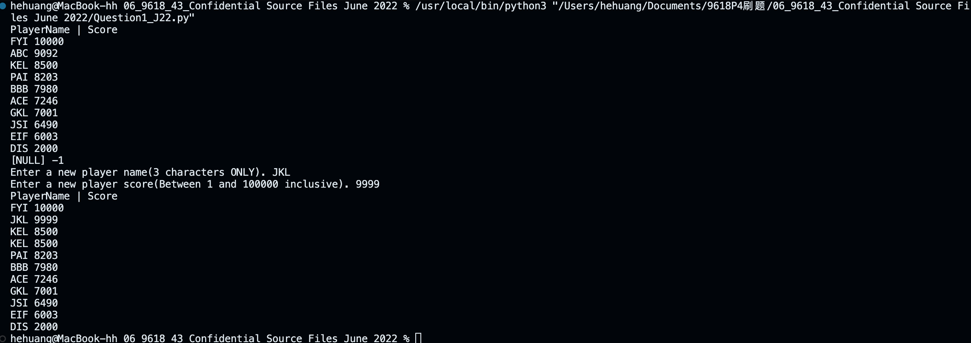

Part 1(f)
{Copy and paste the program code listing for question 1(f) here}

def WriteTopTen():
global Mark
global Name
fw=open("NewHighScore.txt",'w')
for i in range(10):
fw.write(Name[i]+'\n')
fw.write(str(Mark[i])+'\n')
fw.close()

Question 2
Part 2(a)
{Copy and paste the program code listing for question 2(a) here}

class Balloon:
def __init__(self, h,c,d):
self.__Health=h #PRIVATE Health: INTEGER
self.__Colour=c #PRIVATE Colour: STRING
self.__DefenceItem=d #PRIVATE DefenceItem: STRING

Part 2(b)
{Copy and paste the program code listing for question 2(b) here}
class Balloon:
def __init__(self,c,d):
self.__Health=100 #PRIVATE Health: INTEGER
self.__Colour=c #PRIVATE Colour: STRING
self.__DefenceItem=d #PRIVATE DefenceItem: STRING

def GetDefenceItem(self): return self.__DefenceItem

Part 2(c)
{Copy and paste the program code listing for question 2(c) here}

class Balloon:
def __init__(self,c,d):
self.__Health=100 #PRIVATE Health: INTEGER
self.__Colour=c #PRIVATE Colour: STRING
self.__DefenceItem=d #PRIVATE DefenceItem: STRING

def GetDefenceItem(self): return self.__DefenceItem
def ChangeHealth(self, num): self.__Health+=num

Part 2(d)
{Copy and paste the program code listing for question 2(d) here}
class Balloon:
def __init__(self,c,d):
self.__Health=100 #PRIVATE Health: INTEGER
self.__Colour=c #PRIVATE Colour: STRING
self.__DefenceItem=d #PRIVATE DefenceItem: STRING

def GetDefenceItem(self): return self.__DefenceItem
def ChangeHealth(self, num): self.__Health+=num
def CheckHealth(self):
if self.__Health<=0: return True
else: return False

Part 2(e)
{Copy and paste the program code listing for question 2(e) here}
#main
Balloon1=Balloon(input("Enter the colour of balloon\n"), input("Enter the defence item of balloon\n"))

Part 2(f)
{Copy and paste the program code listing for question 2(f) here}

def Defend(balloon):
Strength=int(input("Enter the strength of an opponent"))
balloon.ChangeHealth(-Strength)
print(balloon.GetDefenceItem())

if balloon.CheckHealth():
print("No health remaining")
else:
print("It still has health")

return balloon

Part 2(g)(i)
{Copy and paste the program code listing for question 2(g)(i) here}
#main
Balloon1=Balloon(input("Enter the colour of balloon\n"), input("Enter the defence item of balloon\n"))
Defend(Balloon1)

Part 2(g)(ii)
{Copy and paste the screenshot for question 2(g)(ii) here}

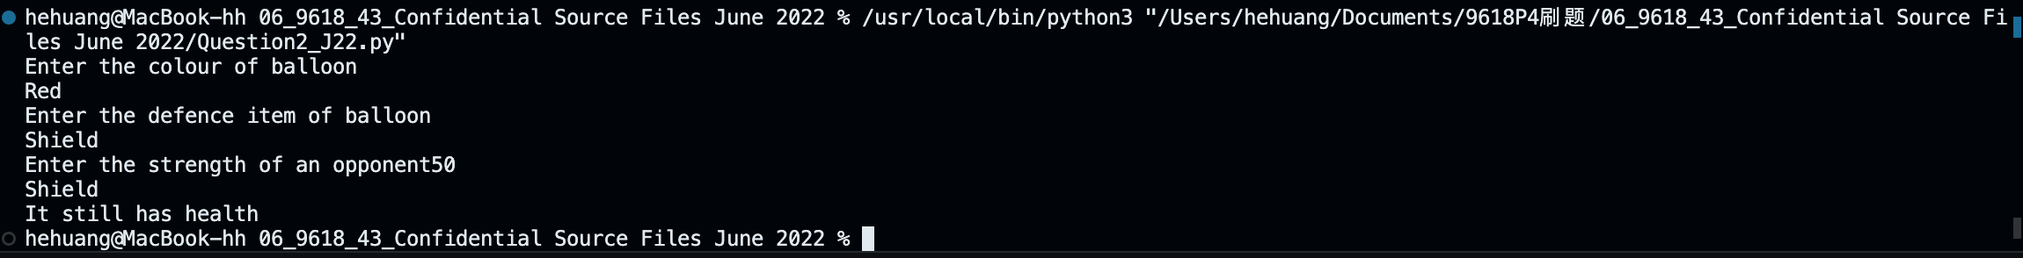

Question 3
Part 3(a)
{Copy and paste the program code listing for question 3(a) here}

#main
QueueArray=["" for _ in range(10)] #DECLARE QueueArray: ARRAY[1:10] OF STRING
HeadPointer=0 #DECLARE HeadPointer: INTEGER
TailPointer=0 #DECLARE TailPointer: INTEGER
NumberItems=0 #DECLARE NumberItems: INTEGER

Part 3(b)
{Copy and paste the program code listing for question 3(b) here}

def Enqueue(DataToAdd):
global QueueArray
global HeadPointer,TailPointer,NumberItems

if NumberItems==10: return False

QueueArray[TailPointer]=DataToAdd
if TailPointer>=9:
TailPointer=0
else:
TailPointer+=1
NumberItems+=1

return True

Part 3(c)
{Copy and paste the program code listing for question 3(c) here}

def Dequeue():
global QueueArray
global HeadPointer,TailPointer,NumberItems

if NumberItems==0: return "FALSE"

ReturnItem=QueueArray[HeadPointer]
if HeadPointer>=9:
HeadPointer=0
else:
HeadPointer+=1
NumberItems-=1

return ReturnItem

Part 3(d)(i)
{Copy and paste the program code listing for question 3(d)(i) here}

#main
QueueArray=["" for _ in range(10)] #DECLARE QueueArray: ARRAY[1:10] OF STRING
HeadPointer=0 #DECLARE HeadPointer: INTEGER
TailPointer=0 #DECLARE TailPointer: INTEGER
NumberItems=0 #DECLARE NumberItems: INTEGER

for j in range(11):
if Enqueue(input("Enter the data to the queue\n")): print("Successfully added.")
else: print("Queue is full, failed to add.")

print(Dequeue())
print(Dequeue())

Part 3(d)(ii)
{Copy and paste the screenshot for question 3(d)(ii) here}

